30. Prolog Program for Forward Chaining
Name:P.Gayathri
Reg.No:192424324

Aim
To write and execute a Prolog program to implement Forward Chaining and derive a conclusion from given facts and rules.
Algorithm
- Start the program.
- Define the initial facts.
- Define rules based on the given facts.
- Select a rule whose conditions are satisfied by the known facts.
- Add the conclusion of the rule to the known facts.
- Continue applying rules until the required goal is derived.
- Display the derived facts and final conclusion.
- Stop the program
Prolog Code:
% Forward Chaining in Prolog

% Initial facts
fact(sunny).
fact(warm).

% Rules
rule(sunny, outdoor).
rule(warm, comfortable).
rule(outdoor, play).
rule(comfortable, happy).

% Forward chaining
forward :-
write('Initial Facts:'), nl,
write('sunny'), nl,
write('warm'), nl,
chain([sunny, warm]).

% Check rules and derive new facts
chain(Facts) :-
find_new_fact(Facts, NewFact),
!,
write('Derived: '),
write(NewFact),
nl,
chain([NewFact|Facts]).

chain(_) :-
write('Forward Chaining Completed.'), nl.

% Find a new fact using the rules
find_new_fact(Facts, NewFact) :-
rule(Condition, NewFact),
member(Condition, Facts),
\+ member(NewFact, Facts).
INPUT:
?- forward.
OUTPUT:
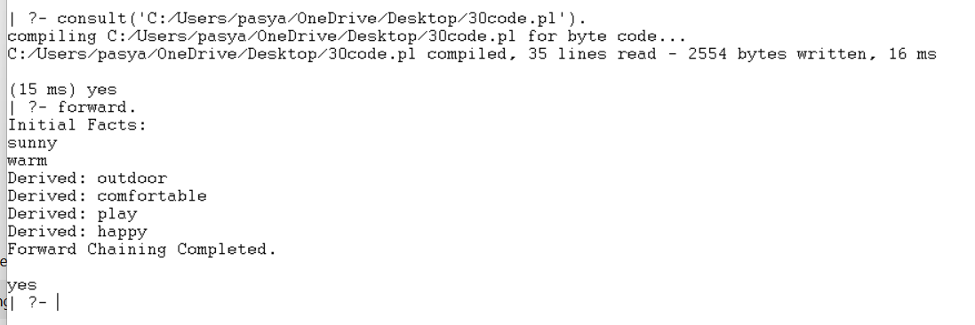
Result:
Thus, the Forward Chaining technique was successfully implemented in Prolog, and new facts were derived step-by-step from the existing facts and rules.

